Case 6-Afr-DR Congo-N’kisi nkondi-Statue-Female-Wood-19th c
Note: The Democratic Republic of the Congo (DR Congo) has been known as, in chronological order, the Congo Free State, Belgian Congo, the Republic of Congo-Léopoldville, the Democratic Republic of the Congo and the Republic of Zaire, before returning to its current name the DR Congo.
Note: The Kongo people (singular: Mukongo, pl. Bakongo) speak Kikongo, a Bantu language, who have lived along the Atlantic coast of Central Africa, in a region that, by the 15th century, was a centralized and well-organized Kongo Kingdom but is now a part of three countries: DR Congo, the Republic of the Congo and Angola.

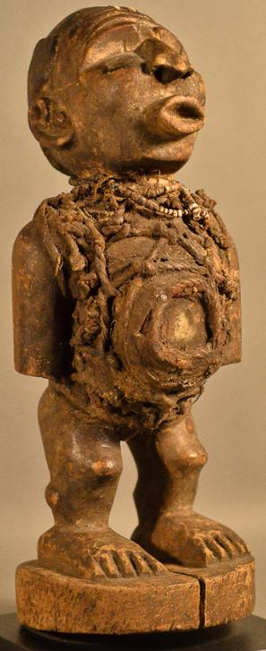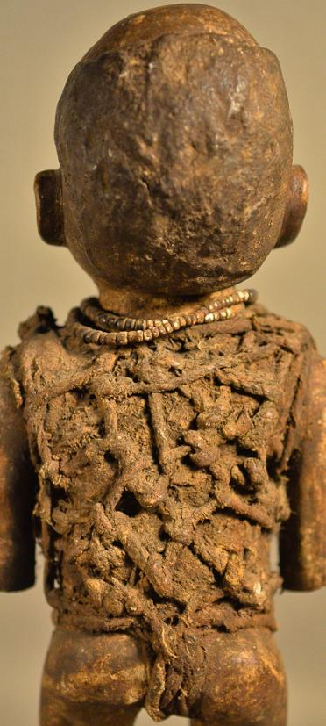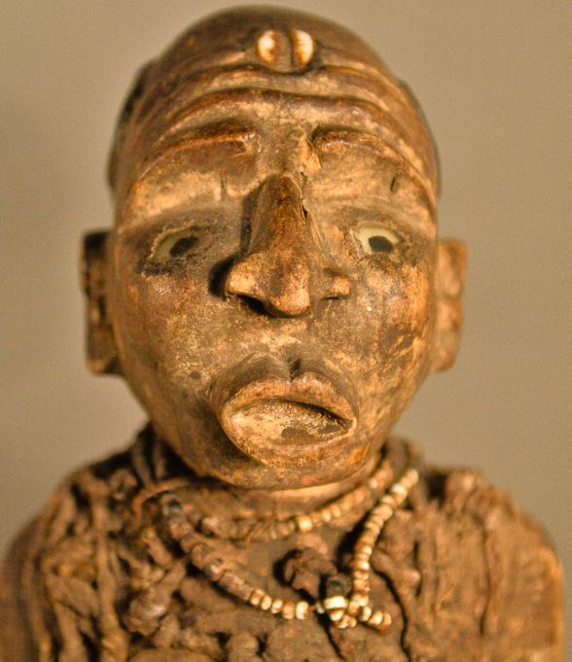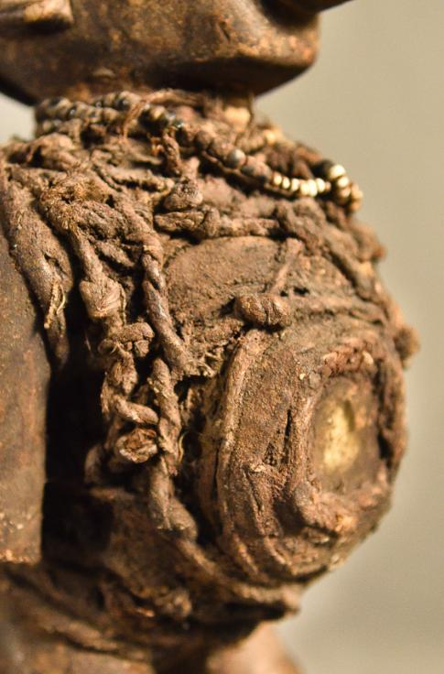
Figs. 1-4. Congo DR- N’kisi nkondi-Statue-Female-Wood-19th c, with shell, fiber, glass and pigments.
Case no.: 6
Accession Number:
Formal Label: Congo DR- N’kisi nkondi-Statue-Male-Wood-19th c
Display Description:

This figure is a nkisi (plural minkisi) of the type known as nkondi (plural minkondi) from the Congo basin in west central Africa. Nkisi is a general term referring to spirits and the objects that house them. Nkondi refers more specifically to the category of objects were carved and animated by hammering nails into its body by nganga (ritual specialists), who would work in conjunction with a supplicant or a separate artisan. The carved figure (usually anthropomorphic, but occasionally taking the form of an animal such as a dog or panther) would act as a container, which would be animated and empowered by the insertion of a parcel of medicine (bilongo).
This nkisi has the physical attributes of a medicine woman and her medicine paraphernalia which is powerless until it has been activated on a particular patient. This nkisi has a classic BaKongo face with expectant glass eyes and wrinkled brow, suggestive of the serious effort being exerted. Its forehead is adorned with a cowry shell which is shaped like the womb and therefore symbolic of successful childbirth (MacGaffey 1988:192). The cowry is "kodya" in BaKongo, which evokes the word "kola", "to be strong", the exhortation of this powerful midwife to the mother-to-be, demonstrated by her protruding lips and everted nose indicating the need for labored breathing and bent knees suggestive of an advantageous child-bearing position. Pregnancy is also emphasized by a protruding belly which is covered with divination objects -- wrappings of rope, roots and a leather pouch, which also contains other powerful but unseen, hence mysterious, objects such as efficacious insects and snake teeth. All of these unseen objects are affixed with secret types of knots securing these hidden objects with their mysterious powers to her body and by sympathetic magic their power is extended to that of the patient. Her arms are at her side, showing attentiveness to the suppliant and are consistent with her well-carved ears suggesting that she is ready to hear entreaties. A small, beaded, white, shell necklace is encrusted with libations demonstrative of years of use.
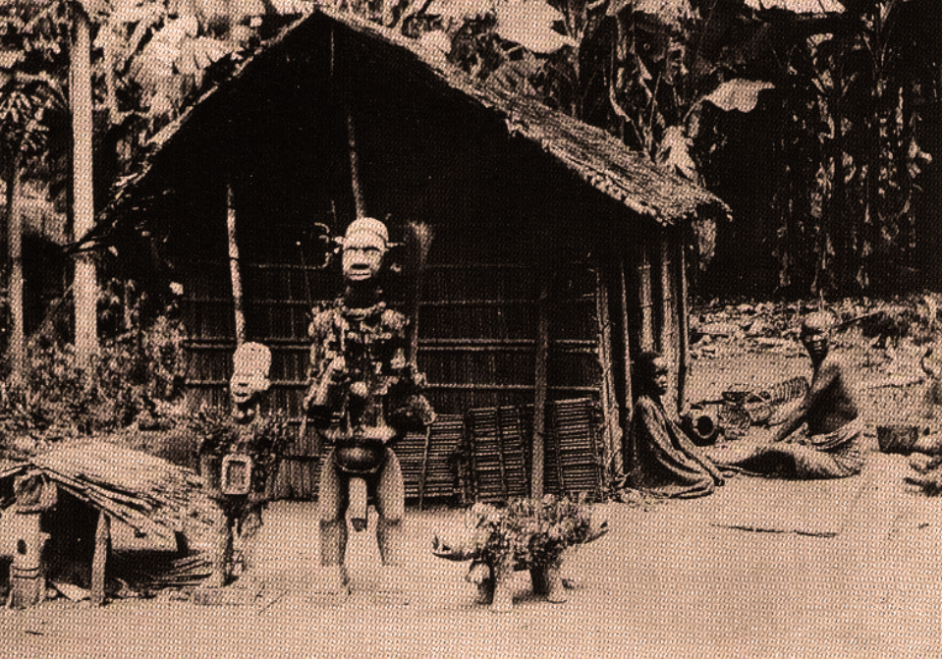
Fig. 5. Three nkisi, two males and a dog, Boma, Congo, 1902. After http://www.randafricanart.com/sitebuilder/images/Nail_fetishes_1902_Boma_Congo-781x515.jpg
In the case of the this nkisi, this bilongo would have been sealed into the cavity on the figure’s abdomen. Once animated by the nganga, supplicants would drive nails and other objects into the nkisi in order to enrage the spirit into action for the purposes of vengeance, protection, healing, or dispute resolution. It has been reported that two nkisi nkonde could be hit together to achieve the same kind of spiritual animation. In other instances, minkondi could be used to sanction an oath; if the oath were broken, the spirit would be released to pursue the party that breached the agreement and to effect a psycho-social restitution. Reflecting this function, nkisi nkondi are often depicted in the pose of hunters, and the word nkondi is derived from the word konda meaning “to hunt.” Nkisi were never intended for aesthetic contemplation as they had an important psycho-social function and were meant to be used to resolve a specific communal purpose.
LC Classification: NB1099 C6
Date or Time Horizon: 19th c
Geographical Area: Congo DR
Map:

INCLUDEPICTURE "../../../../DOCUME~1/ADMINI~1/LOCALS~1/Temp/scl3.jpg" \* MERGEFORMAT 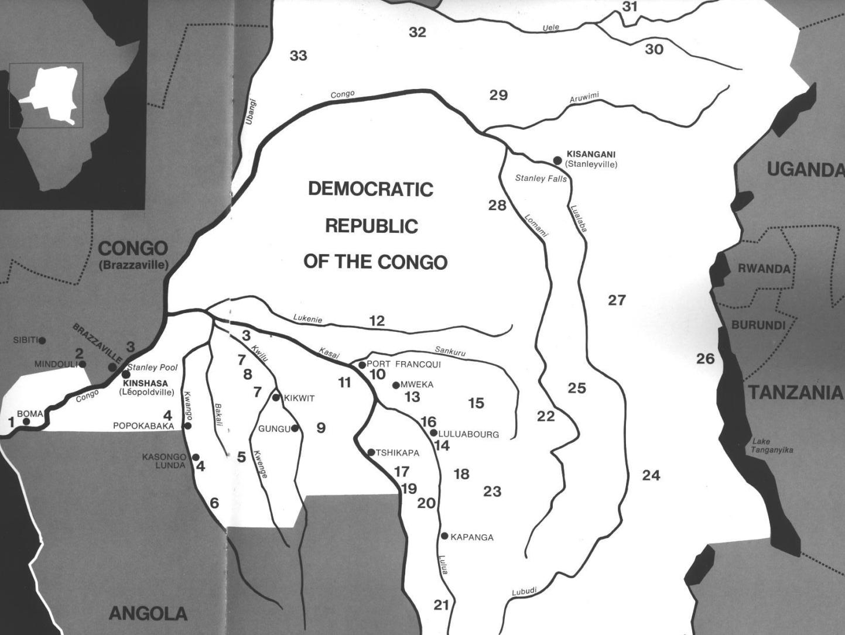
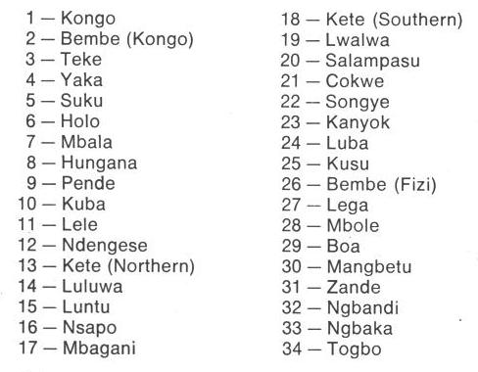
Fig. 1. Map of Kongo Cultures, West Central Africa. After Walker Art Center 1967.

GPS coordinates:
Cultural Affiliation: Kongo
Media: wood, iron nails
Dimensions: H
Weight:
Condition: original
Provenance: Kinshasa
Discussion:
This n’kisi nkondi has embedded iron nails (nkonso) which were hammered into its surface marking the incidences of personal encounters with other humans or spirits and concluding with resolution (Laman 1953, vol. 3, p. 86). The totality of these nails presents a remarkable testimony to the efficacy of Kongo psycho-social therapy, since each nail represents such a transaction.
Kongo figural protocol is predicated on animating the object in order that it will be effectively animate. One of the basic demands is that the knees be bent to signify it is a sentient being, which has been engaged by the bilongo or activating energy. This bilongo may also be seen in its gestural language to engage the client. In this case the figure has its right hand raised above its ear as though requesting the client to speak louder, its mouth is open (bamuna) as if it has spoken or is speaking and its left arm is by its side. Its eyes challenge (mambo) the client beseeching him with the power of Kalunga, the spiritual agent, demanding one to divulge the truth. Nails embedded in the figure represent strongly felt desires, requests for protection, requests for defense and empowerment each is sealed with a solemn vow or “tied mambo” (Thompson 1978).

The Songye regarded the n’kisi nkondi sculpture as spiritually devoid until it was energized by bishimba, a sacred “medicine” uniquely prepared by the village Shaman-Sculptor in consultation with his patient or client. Bishimba could be composed of animal, plant, or mineral components, such as a bird of prey’s feathers, a venomous snake’s skin, a dangerous animal’s horn, a predator’s teeth or claws, wood from a tree struck by lightning, earth from the footprint of a dangerous animal. All these things and more could be tied on to the sculpture in containers or pouches or crammed into cavities or channels. In addition, the application of metal to the wooden surface invoked the awesome powers of the village blacksmith, who was associated with the powers of fire whether on the land or lightning in the sky.
The powerful Kuba kingdom ruled by King Kot áPe had the famous Songye sculptor-diviner Kongolo brought n’kisi nkondi to his court in order to ensure the king’s protection and well-being. Kongolo created a set of four personal n’kisi nkondi and a 1908 photograph, taken during the Hungarian ethnographer Emil Torday’s visit, shows King Kot áPe standing next to them.

The so-called “art criticism” of n’kisi nkondi reflects a lack of anthropological context. Kongo communal societies have not engaged in aesthetically designed works and this is true for societies whether they be Western, African, Native American or Eastern. It is pointless to refute those who engage in solely artistic critiques of these objects, since the two planes of reality, art criticism and anthropology, rarely intersect. A good treatment of this debate from one who is familiar with both sides and articulates the issues succinctly, especially with regard to n’kisi nkondi, is Henry Skeritt at https://henryfskerritt.com/2013/01/04/objects-of-power-and-the-power-of-objects/, https://virginia.academia.edu/HenrySkerritt.

References:
Adams, Monni. 1988. 8th century Kuba king figures, African Art 21(3): 32-38, 88.
Belepe, Bope. 1974. Etude socio-morphologique des masques Bwoom des Kuba: Memoire de licence en histoire. Lubumbashi: Université Nationale du Zaire.
Belepe, Bope. 1981. Les oeuvres plastiques Africaines comme documents d'histoire: Le cas des statues Royales Ndop des Kuba du Zaire, AfricaTervuren 25 (1): 9-17.
Binkley, D. 1987. Avatar of power: Southern Kuba masquerade figures in funerary context, Africa 57 (1).
Binkley, D. 1990. Masks, space and gender in southern Kuba initiation ritual, Iowa Studies in Art. Vol. 3, Art and Initiation in Zaire. Iowa City: The University of Iowa.
Brett-Smith, Sarah. 1983. “The Doyle Collection of African Art,” Record of the Art Museum, Princeton University, 42(2): 2+8-34.
Kuba du Zaire, Africa Tervuren 27(1): 9-17.
Binkley, D. 1987. Avatar of power: Southern Kuba masquerade figures in funerary context, Africa 57 (1).
Binkley, D. 1990. Masks, space and gender in southern Kuba initiation ritual, Iowa Studies in Art. Vol. 3, Art and Initiation in Zaire. Iowa City: The University of Iowa.
Claerhout, A. 1976. Two Kuba wrought-iron statuettes, African Art IX (4): 60-64.
Cornet, J. 1972. Art de l'Afrique Noire au pays du fleuve Zaire. Brussels: Arcade.
Cornet, J. 1975. Art from Zaire: 100 Masterworks from the National Collection. New York: African-American Institute.
Cornet, J. 1982. Art royal Kuba. Milan: Sipiel.
Ehret, Christopher. 2002. The civilizations of Africa: a history to 1800. Charlottesville: Virginia: University of Virginia Press.
Forbath, Peter. 1977. The River Congo. Boston: Houghton Mifflin.
Laman, Karl. 1953. The Kongo. 4. vols. Stockholm: Victor Pettersons.
MacGaffey, Wyatt. 1986. Religion and society in central Africa: the Bakongo of Lower Zaire. Chicago: University of Chicago Press.
MacGaffey, Wyatt. 1988. “Complexity, astonishment and power: the visual vocabulary of Kongo minkisi,” Journal of African Studies, (14:2), 188-203.
Martinez-Ruiz, Barbaro. 2013. Kongo Graphic Writing and other Narratives of the Sign. Philadelphia: Temple University Press.
Rosenwald, J. B. 1974. “Kuba king figure,” African Art, VII (3).
Schadeberg, Thilo. 1999. “Batwa: the Bantu name for the invisible people.” In Challenging Elusiveness: Central-African Hunter Gatherers in a Multidisciplinary perspective, ed. K. Beibrouck, S. Elders, and G. Rossel. Leiden: CNWS, 21-39.
Skeritt, Henry. 2013. https://virginia.academia.edu/HenrySkerritt
Thompson, Robert Farris. 1978. “The Grand Detroit N’kondi,” Bulletin of the Detroit Institute of Arts 56 :4, 206-217.
Torday, E. and T. A. Joyce. 1911. « Notes ethnographiques sur les peuples communement appeles Bakuba, ainsi que sur les peuplades apparentees, les Bushoongo. » In Annales du Musee Royal du Congo Belge, Ethnographie et Anthropologic., serie III, tome II, fasc. 1. Brussels: Tervuren.
Vansina, Jan. 1955 “Initiation Rituals of the Bushong,” Africa 25(2): 138-153.
Vansina, Jan. 1964. Le royaume kuba. Tervuren: Musée royal de l'Afrique centrale.
Vansina, Jan. 1978. The children of Woot. A history of the Kuba peoples. Madison: University of Wisconsin Press/Dawson.
Vansina, Jan. 1984. Art History in Africa. London: Longman.
Van Wing, Joseph Hubert Leopold. 1941. Études Bakongo. II. Religion et magie. Institut royal colonial belge. Section des sciences morales et politiques. Mémoires, collection in-8°, t. IX, fasc. 1. Brussels: Desclée de Brouwer.
Van Wing, Joseph Hubert Leopold. 1959. Études Bakongo. Brussels: Desclée de Brouwer.
Walker Art Center. 1967. Art of the Congo. Minneapolis: Walker Art Center.

